CS628 Full-Stack Development Web App

**PE03 – ToDo List App**

School of Technology & Computing (STC)

City University of Seattle (CityU)

**Before You Start**

* You already created a private GitHub repository for all your programming exercises, “cs628-pe-your_first_name.”
* You allowed your instructor and the Teaching Assistant to access your GitHub repository for programming assignments.
* The GitHub Codespaces may bill your account according to your usage. Check the price at <https://docs.github.com/en/billing/managing-billing-for-github-codespaces/about-billing-for-github-codespaces>. Please pay attention to the storage and core hours of use free of charge for personal accounts.
* Some steps are not explained in the assignment**.**If you are not sure what to do:
  + Consult the resources listed in your course.
  + If you need help solving the problem after a few tries (~15 minutes), ask a TA for help.

**Learning Outcomes**

Students will be able to:

* + Create a basic ToDo list app using React, utilizing state management with the useState hook to handle dynamic data.
  + Implement event handlers to capture user interactions, and dynamically render components.

**Problem Statement:**

Your goal is to create a basic ToDo list App using React that allows users to add and remove todos.

**Requirements:**

* Display an input field where users can enter their ToDo description.
* When the "Add Task" button is clicked, the ToDo should be added to the ToDo list.
* Each ToDo in the list should have a "Delete" button that allows users to remove the ToDo.
* Implement state management using the useState hook to handle the list of ToDos.

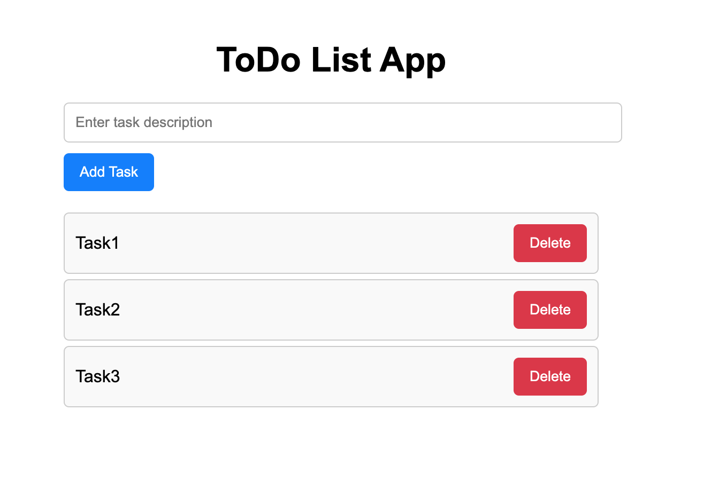

**Note:**

* Create separate components for the ToDo list and ToDo tasks.
* Use the useState hook to manage the state of the ToDos.
* Implement event handlers to capture user interactions, such as clicking the "Add Task" or "Delete" buttons.
* Use the .map() function to dynamically render the list of ToDos.
* Apply CSS styling of your choice to enhance the user interface.

**Submission**

1. Create a GitHub repository for your programming exercises. The repository name will be “cs628-pe-*your_first_name*.”

1

1. Click the Settings menu. Invite your instructor and TA to collaborators.

1

1. Under the repository, create a directory for the programming exercise 1, “PE03-ToDoList.” For example, the screen below shows the directory created for programming exercise 01.

1. Finish your programming exercise under the PE03 directory.
2. Write a 150-word analysis report to explain how the program works in [README.md](https://www.markdownguide.org/basic-syntax/) in terms of the [input-process-output model](https://press.rebus.community/programmingfundamentals/chapter/input-process-output-model/). The README.md has three level-1 headings – Input, Process, and Output.
3. Submit the link of your GitHub repository to your course shell through your assignment submission.

